A paper review about the Chapter 3 of the ENSEMBLE CONTROL OF ROBOTIC SYSTEMS by Aaron T. Becker

Yu Huang

1. **Goals**

This chapter mainly is mainly focused on the discussion of the canonical plate-ball system and proved the controllability under model perturbation which “scales the ball radius by an unknown but bounded constant” [1]. This chapter proved the system still controllable and proposed an algorithm for approximate open-loop steering whose basic idea is to “maintain the set of all possible configurations of the sphere and to select inputs that reduce the size of this set and drive it toward some goal configuration”[1]. On the other hand, the chapter also offered a different version of the plate-ball experiment which was based on magnetic actuation.

1. **assumptions**

First and foremost, the paper assumed that the bounded but unknown variable $ε$ linearly determined the feature dimension of the system in this way:

$$r_{i}=\frac{R}{ε}$$

After the controllability proof of the plate-ball system, the author used the approximation technique to accomplish the result that only using the actuated 2 degree of freedom to steer the balls to a desired orientation. What`s more, in this chapter, the author also propose the expression of the steering error of the open loop control system by the utilization of the Taylor series. With the expression of the steering error, we can easily analyze the cause of the open loop control error and this paper also offered some ways to decrease it along with several discussions of controlling the error.

1. **Limitations**

Generally, this chapter studied the canonical plate-ball system from theoretical and practical perspective. The major work is the proposition of the steering algorithm of the balls which can generate a seemingly impossible motion of the system. See table1:

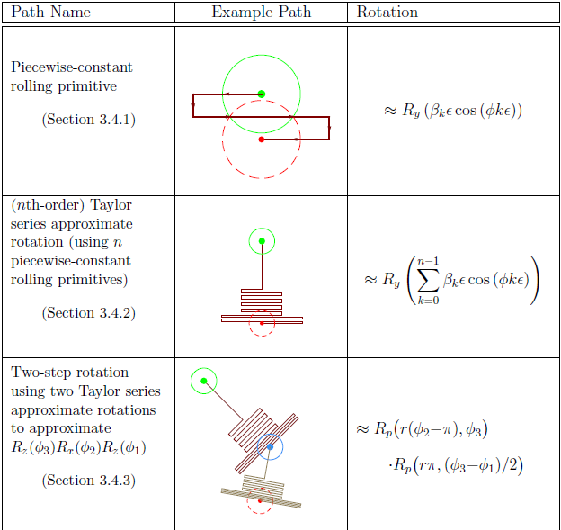

Table.1. implementation of generating seemingly impossible motion

However, this chapter did not asses the convergence time nor did it prove whether the system has the exponential convergence property. Besides, as pointed in the assumption part, the paper studied the unknown but bounded relation of this form:

$$r_{i}=\frac{R}{ε}$$

There could be other forms.

For the implementation part, the paper proved the feasibility of the steering algorithm but did not include the observation of the steering of the balls although it offered prediction of it. Therefore, those are all the promising future work.

[1] Becker, Aaron. "Ensemble control of robotic systems." PhD diss., University of Illinois at Urbana-Champaign, 2012.